**Use Case Diagram of Job Recommendation System**

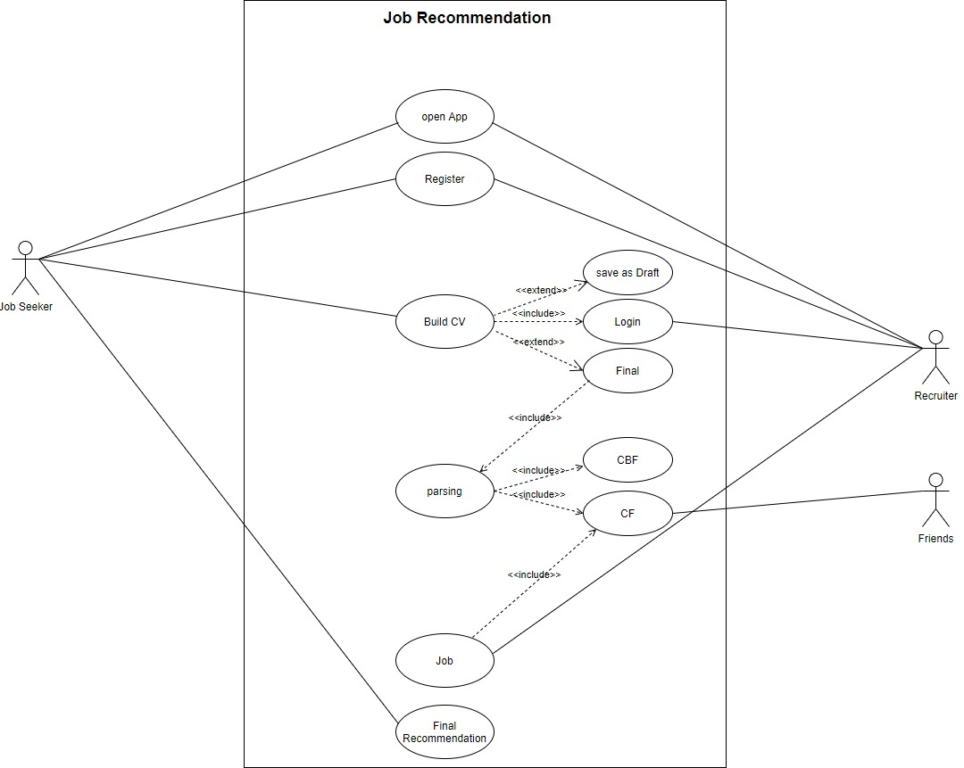

***Extended Use-Cases***

1. Open App

|  |  |  |
| --- | --- | --- |
| 1 | Use-Case ID | 01 |
| 2 | Use-Case Name | Open App |
| 3 | Actor/User/Stakeholder | * Job Seeker * Student * System Admin * Recruiter |
| 4 | Pre-Conditions | * User must have Job recommendation system * Must have appropriate space to run efficiently |
| 5 | Main Successful Scenario/Action | * User will install and open the system * By Default, Register page will opened |
| 6 | Alternate Actions | * User might don’t interact with the system * User will see nothing |
| 7 | Triggers | * When user wanted to get Job * User interact with the system and open it * If recruiter wants to publish new Jobs, the he/she open app and published Jobs |
| 8 | Post Conditions | * App will be opened * User move to the registration page to perform further operations |

1. Register

|  |  |  |
| --- | --- | --- |
| 1 | Use-Case ID | 02 |
| 2 | Use-Case Name | Register |
| 3 | Actor/User/Stakeholder | * Student * Job Seeker * System Admin * Recruiter |
| 4 | Pre-Conditions | * User must have Job recommendation system * System should be functioning properly * User must be on register page |
| 5 | Main Successful Scenario/Action | * User enter his credentials which are required by the system * Record must be unique * User click on register to submit form |
| 6 | Alternate Actions | * If record is not unique or having missing attributes, then the user is unable to register in the system successfully * User again come to the registration page to register himself/herself again |
| 7 | Post-Conditions | * User become registered * User go on to the login page to perform further operations * After this user login the system |
| 8 | Triggers | * When user opened app, registration page is displayed on the screen to get registered |

1. Login

|  |  |  |
| --- | --- | --- |
| 1 | Use-Case ID | 03 |
| 2 | Use-Case Name | Login |
| 3 | Actor/User/Stakeholder | * Job Seeker * Student * Recruiter * Admin |
| 4 | Pre-Conditions | * User must have Job recommendation system * Job seeker and recruiter must be registered before login |
| 5 | Main Successful Scenario/Action | * After registration, user move to the login page * Job seeker and recruiter logged in the system to perform required tasks * After logged in, user moved to the dashboard |
| 6 | Alternate Actions | * User (Job seeker or recruiter) is unregistered * User entered invalid login credentials * User cannot be logged in and don’t have an access to move further in the system |
| 7 | Post-Conditions | * User must be signed in * User moved to the home page/dashboard * Job seeker can build CV and the recruiter can publish Jobs. |
| 8 | Triggers | * After registration successfully, system move to the login page and ask the user to enter credentials to use system effectively and safely |

1. Build CV

|  |  |  |
| --- | --- | --- |
| 1 | Use-Case ID | 04 |
| 2 | Use-Case Name | Build CV |
| 3 | Actor/User/Stakeholder | * Job Seeker * Student |
| 4 | Pre-Conditions | * Job seeker must have Job recommendations system * Job seeker must be registered * Job seeker must be logged in |
| 5 | Main Successful Scenario/Action | * After login, Job seeker click on build CV * Form will be opened * User enter all his details about his professional career and personal life. * Click on Create CV. CV is created successfully * CV is parsed based on content based and collaborative (friends with same interest) filtering in the system |
| 6 | Alternate Actions | * If Job seeker is unregistered or not logged in, he/she is not able to create CV * Without CV, Job seeker cannot get Job recommendations |
| 7 | Post-Conditions | * CV is created successfully * Job seeker move to the next page * Job seeker able to request to get final recommendations |
| 8 | Triggers | * When Job seeker logged in, he/she click on Build CV button to start creating CV. This event cause this use case to initiated |

1. Job

|  |  |  |
| --- | --- | --- |
| 1 | Use-Case ID | 05 |
| 2 | Use-Case Name | Job |
| 3 | Actor/User/Stakeholder | * Recruiter |
| 4 | Pre-Conditions | * Recruiter must be registered and signed in * Recruiter have Jobs to add it in the system |
| 5 | Main Successful Scenario/Action | * Recruiter login the system * Recruiter add Jobs in the recommendation system and publish it * These Jobs are matched with the Job seeker contents in the CBF |
| 6 | Alternate Actions | * Recruiter is invalid/unauthorized * Recruiter is unable to publish Jobs for the Job seeker |
| 7 | Post-Conditions | * Recruiter logged in * Recruiter published Jobs for the Job seeker successfully |
| 8 | Triggers | * Recruiter published Jobs for the seeker to start recommendations * When recruiter logged in, system show publish Job or add Jobs button to the recruiter to publish Jobs for the Job seeker |

1. Final Recommendation

|  |  |  |
| --- | --- | --- |
| 1 | Use-Case ID | 06 |
| 2 | Use-Case Name | Final Recommendations |
| 3 | Actor/User/Stakeholder | * User * End-User * Job Seeker |
| 4 | Pre-Conditions | * User CV must be parsed * CBF and CF (with same interest) applied * Recruiter Jobs are checked |
| 5 | Main Successful Scenario/Action | * User request to get final recommendations for Jobs * Job recommendations are showed/displayed to the Job seeker * Job descriptions are provided to the Job seeker |
| 6 | Alternate Actions | * If the Jobs and user credentials are mismatched, then the system show an error message to the seeker * Job seeker can try again |
| 7 | Post-Conditions | * All related Jobs are print out to the Job seeker on the screen * User view the all details related to his requirement |
| 8 | Trigger | * User request to see recommendations * Click on final recommendations and the Jobs are shown if user record meet the recruiter requirements |

**Sequence Diagram of Job Recommendation System**

